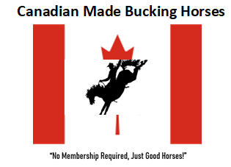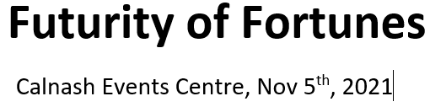
Bucking Horse Sale Consignment Form
NAME OF HORSE ____________________________ #________ CIRCLE ONE: BB SB FU
DELIVERY: ______ AGE _____ COLOR ________SEX ________
CMBH Locations competed at ________________________________________________________
OWNER __________________________________________________________________________ ADDRESS _________________________________________________________________________ TELEPHONE & EMAIL ________________________________________________________________
Sale Terms:
1. All horses sold to a US buyer will require before shipping a negative Coggins, health certificate, and brand papers. No exceptions.
2. 10% Auction Commission and 1% Auctioneers Commission
3. Sale entry will be $150 per horse, 3 or more entered will be $125 per horse which must be paid with the entry of the horse by Oct 1st, 2021. If a horse is removed before the sale the entry fee will not be refunded.
4. Buy back fee will be the sale commission percent charge based on the last bid “but” with the return of your sale entry fee.
5. If you want your livestock insured you will have to provide it yourself.
6. The seller is responsible for 50% of the trucking charge to a US destination point, Billings, MT ($200) or Las Vegas, NV ($375) the week prior to the start of the 2021 NFR.
7. If a horse is sold to a US buyer, the seller shall retain ownership of the horse until the buyer has possession of the horse once it has landed in one of the two outlined destinations.
8. If a horse is sold to a US buyer, VJV Auctions (Bonded and Licensed) will hold proceeds from the buyer until the horse has been delivered and is in possession.
9. A overnight fee of $10 per horse will be charged at time of entry if the animal has an overnight stay.
10. Canadian Made Bucking Horses, its producer or VJV Auctions will not be financially liable for any horse before, during or after the sale or bucking event.
I ____________________________ (the seller) have acknowledged that he has read and agreed to the terms, understands this is a binding contract between the seller, Canadian Made Bucking Horses and VJV Auctions.
SIGNATURE OF CONSIGNOR _________________________________ Date ________________

